Written protocol for running dicty cells in the cell race chip

- Starvation protocol
- Device priming with chemoattractant
- Cell loading
- Time-lapse microscopy

1. Starvation protocol (if you are using dicty cells!)

- Harvest cells from either a plate or shaking culture, use at least 4*10⁶ cells in total
- Wash the cells twice in PB buffer
- Resuspend the cells to a concentration of 2-3*10⁷cells/ml
- Put the cells in an Eppendorf with a round bottom (2ml tube instead of standard 1.5ml)
- Put the cells on a rotor or tumbler at about 20RPM for 6hrs
- After 6 hrs spin down the cells and resuspend until you have a concentration of 1*10⁸cells/ml
- Immediately load this solution into the prepared maze

NOTE: If you are using mammalian cells, load isolated cells at at least 30-50 million cells/mL. Whole blood may be used at a 1:1 dilution with the cell media and heparin (to prevent coagulation).

2. Device priming with chemoattractant – using a Syringe

- With a 1 mL syringe, first pull about 200 uL of air. Then, pull about 700 uL to 800 uL of chemoattractant solution. Add the 18-gauge blunt end needle.
- Holding the syringe upright so that the blunt end is towards the ceiling, press gently until liquid comes out the needle. This assures that all air bubbles are gone.
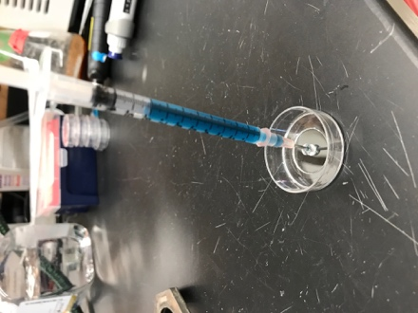
- Gently insert needle half-way into loading port of device, should be a snug fit and syringe should be able to stand on its own while in device (Figure A).
A

- Push syringe down loading about 50 uL-100 uL into device, with some force*. Solution should be coming out the side ports (Figure B).
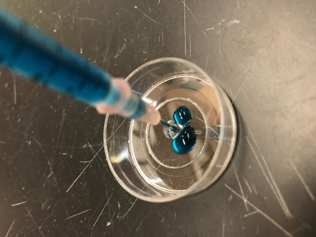
B
- Looking under the microscope, you should see that some of the end chambers will be partially loaded, if the correct force was applied (Figure 2C). Too little force and chambers will remain empty. With some force, push down on the syringe in 50 uL “spurts”. Leave a few seconds between pushes or the syringe will pop out due to much pressure. Keep the device under the microscope so you can observe the air pockets remaining get replaced by the solution.
- Repeat until all chambers are full (Figure 2E). Re-fill the syringe if necessary. BE CAREFUL to have the syringe loaded adequately enough so you are not pushing air into device**
- Once device is completely loaded with chemoattractant, wash device using 10 uL of the media your chemoattractant is in. So if you used a buffer solution or PBS to make your chemoattractant use that. Repeat with another 10 uL. This step can be done using a 10 uL pipette. Make sure you are ready to load your cells imediately after washing. If you are not prompt the gradient will weaken and your cells will not move as fast as they could!
- Cover device with media for the cells (usually 3 mL), so your device does not dry out.

* Too much force may cause the device to pop off or completely be destroyed or cause the syringe to pop out splattering the solution everywhere.
** So you are not making massive amounts of chemoattractant you can use the extra solution that comes out of the device

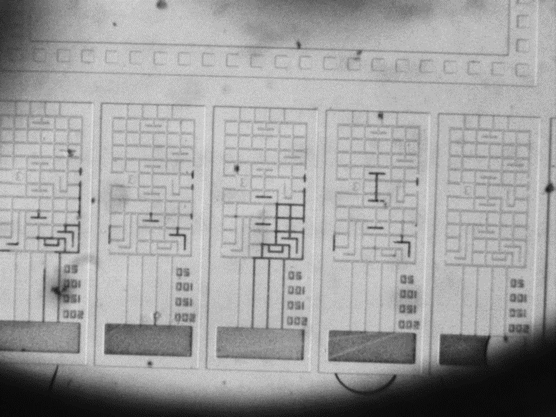
3. Cell loading
Figure 1- Incomplete priming, dark areas are air

- Take 5 µl of the cell suspension and slowly inject into the maze using a thin tip on a 20µl pipette. You don’t have to inject all! Stop when you see a white cloud of cells coming out from the sides. Note: Do not be too forceful when pipetting in cells.
- Check the maze again if there are any air bubbles and if the cells were loaded
  - You might see ebbing and flowing of the liquid, this is normal. Just keep slowly forcing more solution through

4. Timelapse imaging

Note: You can access these videos online on the cytosmart website and watch in real time as the race progresses.

Animated Protocol for using Mini Microscope

- Microscope set up

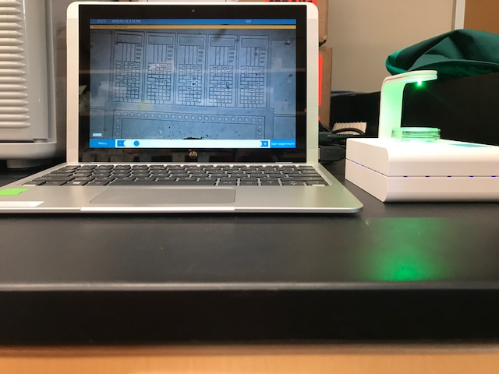

- Zoom In and focus on two mazes. Zoom In can be found under the menu tab on the bottom left hand corner. Focusing can be done by hitting the plus or minus on the bottom or sliding the circle left to right.

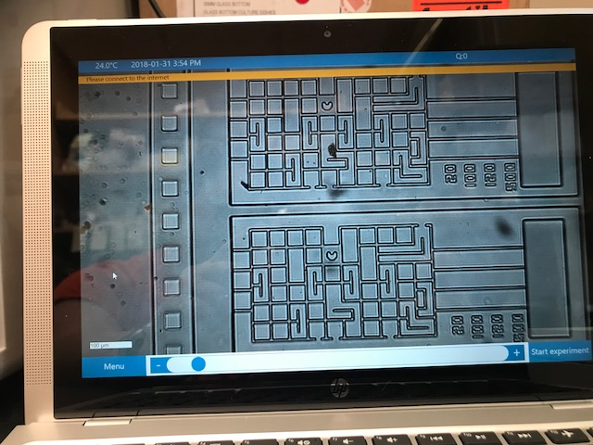
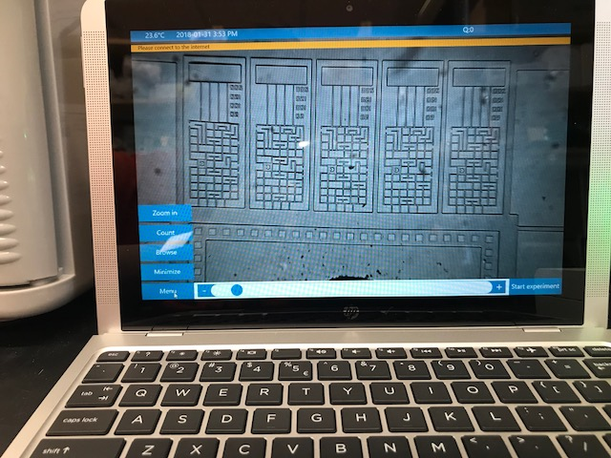

- Hit “Start Experiment”. A sign in page will pop up. You will need to create an account with Cytosmart.
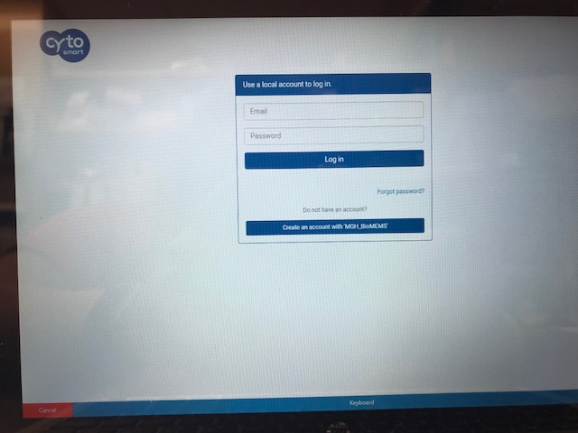

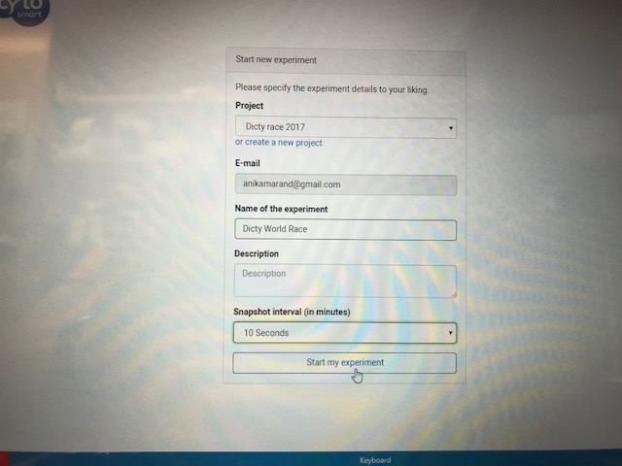
- Once you are logged in a new experiment set up page will appear. Add your email you used for your account, the name of your experiment and under description put your cell type and chemoattractant used. Change snapshot interval to 10 seconds. Then hit “Start my experiment”.

- You should see this picture above once the experiment has started. To end experiment hit “Stop Experiment” in the bottom right hand corner. You will know its recording due to the red dot that appears in the upper right hand side.
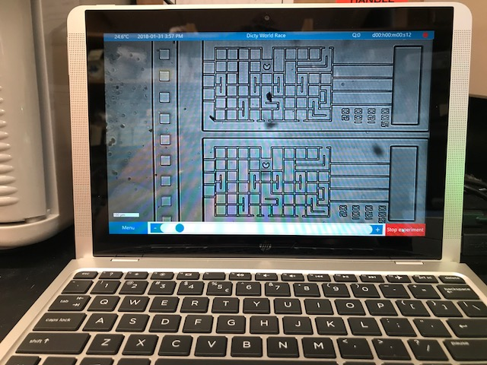

Some extra tips if you have trouble filling up the maze:
- Some bubbles might take some time to go away, you might just have to wait
- Try to remove some chemo-atracctant from around the maze, creating suction on that side
- Apply more force on the syringe when loading
Figure 2- C- incomplete priming of device. D- mostly complete priming of device. E- correctly primed device.
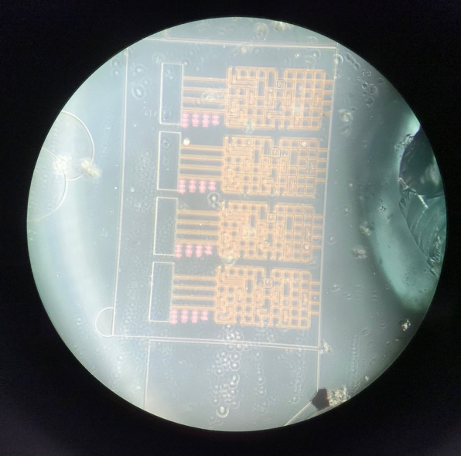
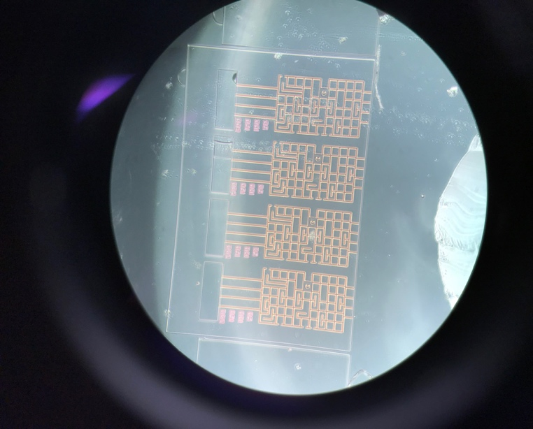
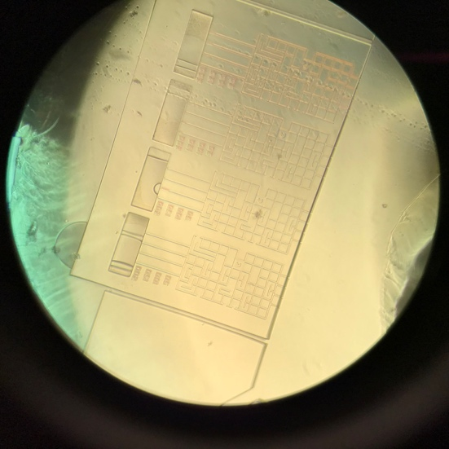
- Figure shows the layout of the device you will using to race your cells
E
D
C

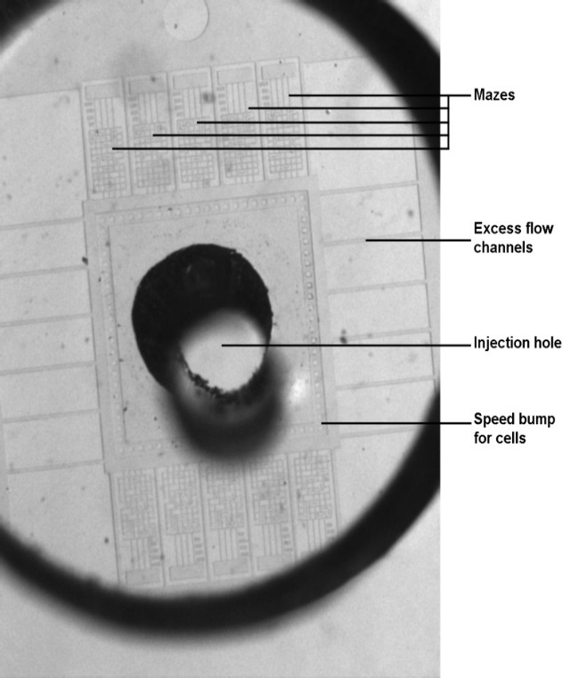
Figure 3-Overview of race chip
- Contact Anika Marand via email : anikamarand@gmail.com or amarand@mgh.harvard.edu if you have any questions or further trouble loading the devices.

